**Supervised Machine Learning**

Supervised learning is the types of machine learning in which machines are trained using well "labelled" training data, and on basis of that data, machines predict the output. The labelled data means some input data is already tagged with the correct output.

## How Supervised Learning Works?

In supervised learning, models are trained using labelled dataset, where the model learns about each type of data. Once the training process is completed, the model is tested on the basis of test data (a subset of the training set), and then it predicts the output.

The working of Supervised learning can be easily understood by the below example and diagram:

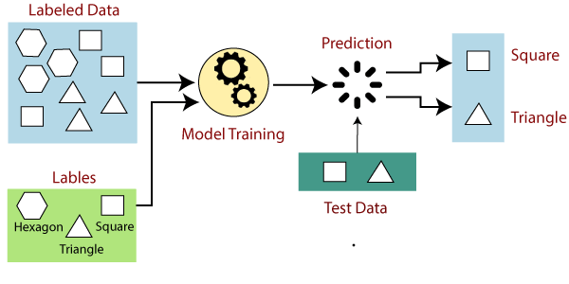

Suppose we have a dataset of different types of shapes which includes square, rectangle, triangle, and Polygon. Now the first step is that we need to train the model for each shape.

* If the given shape has four sides, and all the sides are equal, then it will be labelled as a **Square**.
* If the given shape has three sides, then it will be labelled as a **triangle**.
* If the given shape has six equal sides then it will be labelled as **hexagon**.

Now, after training, we test our model using the test set, and the task of the model is to identify the shape.

The machine is already trained on all types of shapes, and when it finds a new shape, it classifies the shape on the bases of a number of sides, and predicts the output.

## Types of supervised Machine learning Algorithms:

Supervised learning can be further divided into two types of problems:

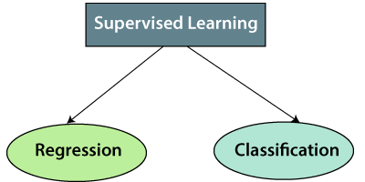

**1. Regression**

Regression algorithms are used if there is a relationship between the input variable and the output variable. It is used for the prediction of continuous variables, such as Weather forecasting, Market Trends, etc. Below are some popular Regression algorithms which come under supervised learning:

* Linear Regression
* Multiple linear Regression
* Support vector Reression
* Regression Trees/decision tree Regression
* Non-Linear Regression
* Random forest regression
* Bayesian Linear Regression
* Polynomial Regression

**2. Classification**

Classification algorithms are used when the output variable is categorical, which means there are two classes such as Yes-No, Male-Female, True-false, etc.

Spam Filtering,

* Random Forest classification
* K_nearest (KNN)
* Decision Trees classified
* Logistic Regression
* Naïve bayes classiffication
* Support vector Machines classification